**BLDC MOTOR SPEED CONTROL WITH RPM DISPLAY**

**ABSTRACT**

The main objective of this project is controlling speed of BLDC motor and displays its speed using an IR method of speed sensor mechanism. The DC motor has various application used in industries like in drilling, lathes, spinning, elevators and etc. The speed control of the DC motors is very essential. This proposed system provides a very precise and effective speed control system. The user can increase or decrease the speed as per the requirement and the motor will run at that exact speed.

The project is divided into three stages: input, processing and output stage. The input stage consists of entering the required speed through switches. The processing stage provides RPM reference of the motor, by a shaft mounted IR sensor interfaced to the microcontroller in the circuit. The microcontroller develops PWM pulses which are varied with switches to regulate the DC power to the motor such that the desired speed is achieved. The output stage uses a MOSFET being driven by the microcontroller output. A PIC family microcontroller is used with a set of switches to increase or decrease the speed of the BLDC motor. This speed is sensed by the sensors and is given to microcontroller which in turn displays it on a LCD display. The above operation is carried out by using one opto-isolator and a MOSFET for driving the BLDC motor. IR sensing is used for getting the speed reference to the microcontroller.

**BLOCK DIAGRAM**

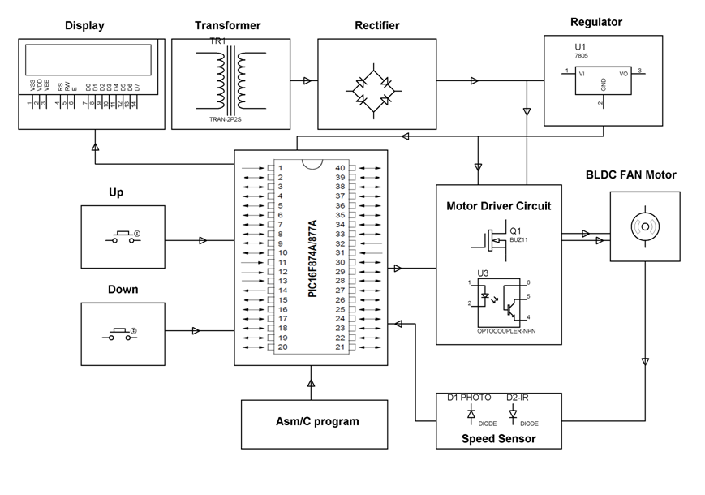

**SOFTWARE REQUIREMENTS:**

HI-TECH PICC Tool suite

Language: Embedded C or Assembly

**HARDWARE REQUIREMENTS:**

PIC series Microcontroller, Crystal, BLDC Motor, LED, Resistors, Capacitors, Diodes, IR led and Photo diode, Voltage Regulator, Push Buttons.